Revision History
Date | Version | Description | Author
09/11/2016 | 0.01 | 1 Introduction, 2 Software Architecture Overview, 4 COTS Identification | Mehmet Uluç Şahin
09.11.2016 | 0.02 | Software Design Description added for Model component. (3.1) | Mehmet Melih Arıcı
09.11.2016 | 0.03 | Software Design Description added for View component. (3.2) | Eren Balatkan
09.11.2016 | 0.04 | Software Design Description added for View component. (3.3) | Arda Mutlu  Berkay Bayram
15.11.2016 | 0.05 | Software Design Description modified for Model component. (3.1) | Mehmet Melih Arıcı

TABLE OF CONTENTS
Revision History 1
1 Introduction 3
1.1 References 3
1.1.1 Project References 3
2 Software Architecture overview 3
3 Software design description 3
3.1 Component 1 3
3.1.1 Component interfaces 4
3.1.2 Component design description 4
3.1.3 Workflows and algorithms 4
3.1.4 Software requirements mapping 4
3.2 Component 2 4
3.2.1 Component interfaces 4
3.2.2 Component design description 5
3.2.3 Workflows and algorithms 5
3.2.4 Software requirements mapping 5
3.3 Component 3 5
3.3.1 Component interfaces 5
3.3.2 Component design description 5
3.3.3 Workflows and algorithms 5
3.3.4 Software requirements mapping 5
4 COTS Identification 6

Introduction

This document describes the design of the RMS software system. This document is supposed to be a guidance to the architecture of this software project and outlines all parts of the software and how they will work.

References

Project References

# | Document Identifier | Document Title
1 | 002 | Software Requirements Specifications

Software Architecture overview
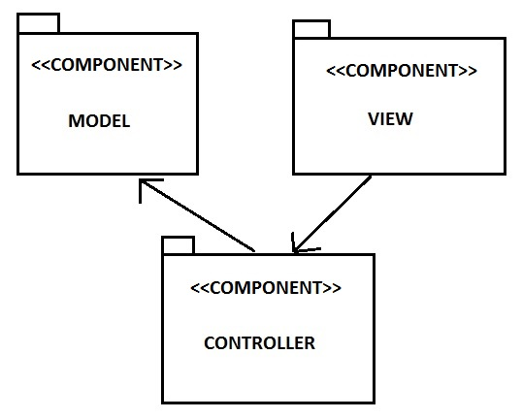

Software design description
This part describes each top level component of RMS.

Component 1
Model

Component interfaces

int getBuildingID ()
int getID ()
int getUserID ()
int getReservationID (int userID)
void addNewReservation (int userID, int startTime, int endTime, int roomID)
void updateStatus (string status)
Room getRoom (int roomID)
void addRoom (Room room)
void deleteRoom (Room room)
void addNewReservationToDB (Reservation reservation)
void giveDetails ()

Component design description
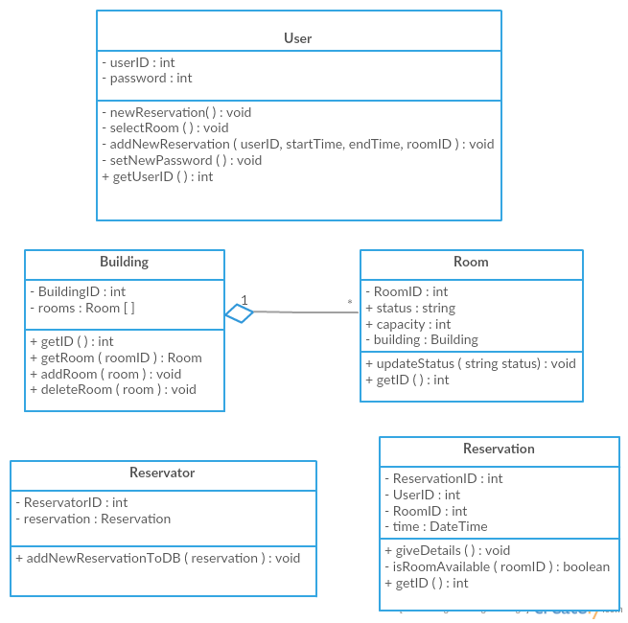

Workflows and algorithms
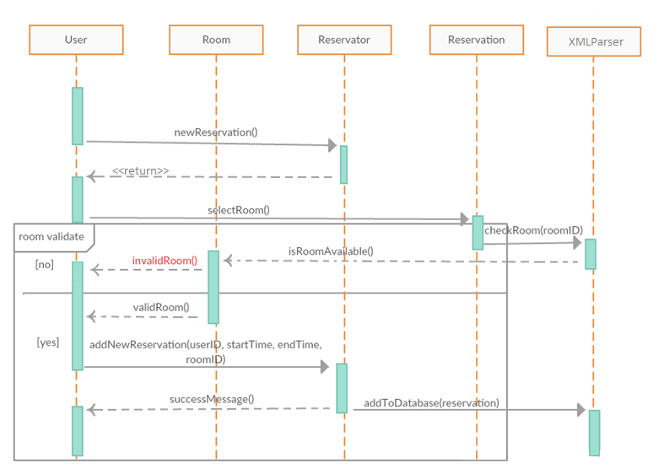

Software requirements mapping
SRS-SQ-RMS-020.0 – Database connection
SRS-SQ-RMS-030.0 - Database connection
SRS-SQ-RMS-040.0 – Room Reservation
SRS-SQ-RMS-050.0 – Room Reservation Cancellation

Component 2
View

Component interfaces
void updateView()
void changeView(int viewCode)

Component design description
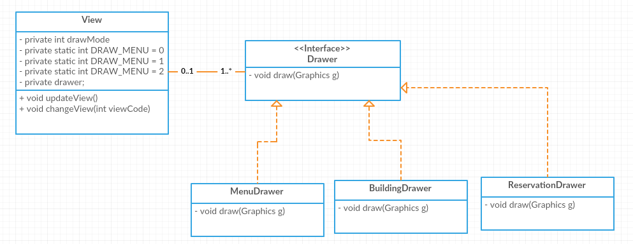

Workflows and algorithms

updateView: Requests fresh data from controller and re-draws the frame according to the new data
changeView: This method is called by the controller to tell the view what it is going to draw ( Menu, Building , etc..)
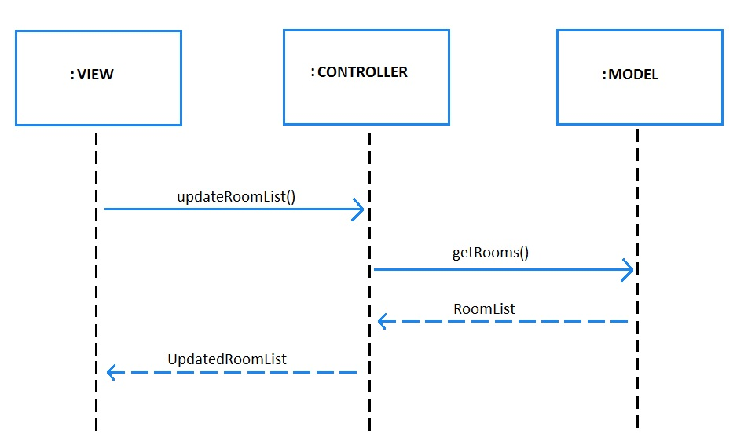

Software requirements mapping
SRS-SQ-RMS-040.0 – Room Reservation
SRS-SQ-RMS-050.0 – Room Reservation Cancellation

Component 3
Controller

Component interfaces
-

Component design description
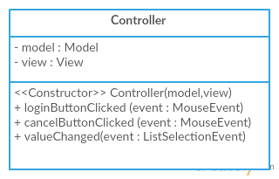

Workflows and algorithms

Software requirements mapping
SRS-SQ-RMS-010.0 – Login system
SRS-SQ-RMS-040.0 – Room Reservation
SRS-SQ-RMS-050.0 – Room Reservation Cancellation

COTS Identification
RMS will not use any external components/libraries.

